Pass Task 10 – The Spell Book

# Related Learning Outcomes

# ULO1 – Explain the OO Principles

This exercise demonstrated object encapsulation

# ULO2 – Use OO Language and Library

Demonstrated class and constructor declaration, the use of conditional statements (e.g. “if”), and assigning values to parameters. Uses of List<> and index this[int i] by accessing library using system.Collection.Generic, use readonly field.

# ULO3 – Design, Develop and Test using an IDE

The code was developed using Xamarin Studio to build and run the program, as well as integrated debugging features to step and inspect values.

# ULO4 – Communicate using UML Diagrams

I learned how to interpret a UML class diagram and write the related code.

# ULO5 – Describe Elements of Good OO Design

The exercise demonstrated correct use of C# coding conventions.

# Screenshots

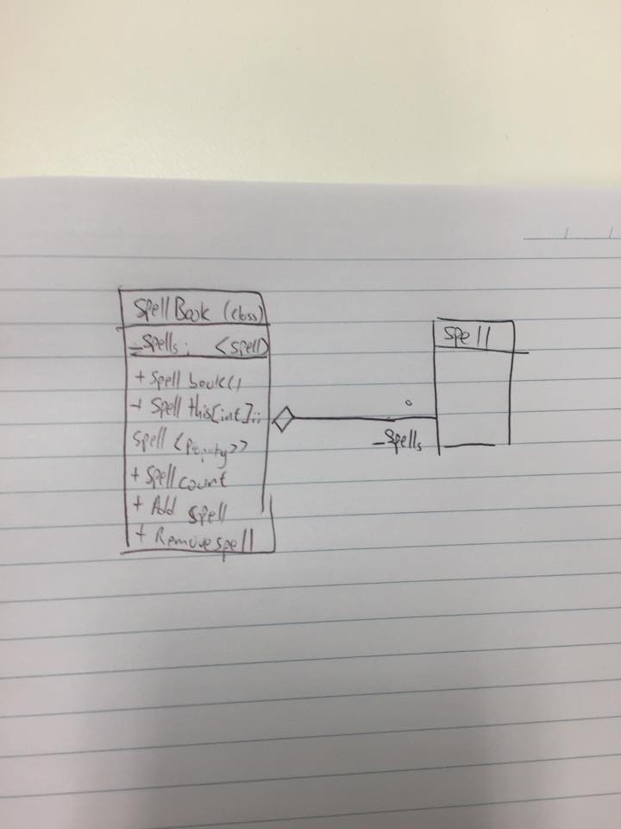

[code running]

